

CO3 ASSESSMENT TOOL 2 – CODE REVIEW & REPOSITORY EVALUATION

Department of Computer Science and Engineering

Project: SmartCare Assets — Intelligent Hospital Asset Tracking
and Equipment Management Platform
Field | Details
Course Code | CSA1012
Course Title | Software Engineering
CO Assessed | CO3 – Emphasis on containerization, version control, and collaborative development
Assessment | Assessment Tool 2 – Code Review & Repository Evaluation
Student Name | Ashwin S
Register No. | 192311410
Date | August 2026

1. Problem Overview

1.1 Assigned Problem Statement
Hospitals manage thousands of shared, mobile medical assets — ventilators, infusion pumps, ECG machines, and portable monitors — that move continuously between departments. Manual registers and periodic audits cannot keep pace with this movement, leading to lost time searching for equipment and reactive rather than predictive maintenance. The assigned project, SmartCare Assets, implements the backend service for an intelligent hospital asset-tracking platform that addresses this gap.

1.2 Summary of the Implemented Solution
The implemented solution is a FastAPI backend service, backed by PostgreSQL, that exposes REST endpoints to register medical equipment, ingest battery/location telemetry, and search the asset inventory. When telemetry reports a battery level below a configured threshold, the asset is automatically flagged as requiring maintenance. The service is fully containerized with Docker and Docker Compose, and its development history is managed through a Git Flow branching model with feature, release, and hotfix branches, as documented in the companion Git & Docker Technical Assignment for this project.

1.3 Project Objectives
- Provide a single source of truth for where a piece of equipment is and what condition it is in.
- Automatically detect low-battery or maintenance-required conditions from telemetry rather than manual inspection.
- Expose a versioned, testable REST API that later modules (dashboards, alerting) can build on.
- Package the service so it can be deployed consistently across development, staging, and production.

1.4 Key Functionalities
- POST /api/v1/assets/ — register a new asset with a unique asset code and tracking device ID, rejecting duplicate tracking IDs.
- GET /api/v1/assets/search — search registered assets by code or equipment type.
- POST /api/v1/telemetry/telemetry — ingest battery level and location for a tracking ID, auto-flagging low-battery assets.
- GET /health — a health-check endpoint used by Docker's HEALTHCHECK and orchestration tooling.
2. Repository Organization

2.1 Repository Structure
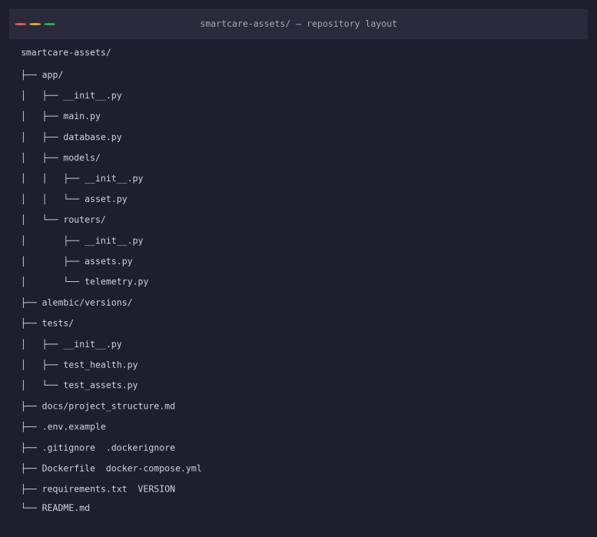
Figure 1: Repository folder structure (smartcare-assets/)

2.2 Evaluation of Structure, Folder Organization, and Naming
The repository separates concerns cleanly at the top level: application code lives under app/, tests under tests/, database migrations under alembic/, and narrative documentation under docs/. Within app/, code is further split by responsibility — models/ for ORM classes and routers/ for route handlers — rather than a single flat main.py containing everything. File names are lower_snake_case and describe their content directly (asset.py, telemetry.py, test_health.py), which is consistent with PEP 8 module-naming conventions and makes the purpose of each file predictable without opening it.

2.3 Justification for Maintainability and Collaboration
Predictable location for new code: a contributor adding a new feature area (e.g., maintenance work orders) knows immediately that a new router belongs in app/routers/ and its model in app/models/, reducing onboarding friction.
Low coupling between layers: routers depend on models and database.py, but models do not depend on routers — this one-directional dependency makes it possible to unit-test the data layer independently of the web layer.
Safe parallel work: because assets.py and telemetry.py are separate files, two contributors (or two feature branches, as shown in the companion Git assignment) can work on different endpoints without editing the same file, minimizing merge conflicts.
Test structure mirrors source structure: tests/test_assets.py and tests/test_health.py map directly onto the routers they exercise, so a reviewer can find the relevant test for any given endpoint immediately.

3. Code Quality Review

3.1 Readability and Modularity
The core asset-registration router is reproduced below as a representative sample:
@router.post("/", response_model=AssetOut)
async def register_asset(payload: AssetCreate, db: AsyncSession = Depends(get_db)):
existing = await db.execute(
select(Asset).where(Asset.tracking_id == payload.tracking_id)
)
if existing.scalar_one_or_none():
raise HTTPException(
status_code=400,
detail="Tracking ID already assigned to another asset",
)
asset = Asset(**payload.model_dump())
db.add(asset)
await db.commit()
await db.refresh(asset)
return asset
This function is short, has a single clear responsibility (validate uniqueness, then create), and uses descriptive names (existing, payload) that make intent obvious without comments. Pydantic models (AssetCreate, AssetOut) separate the request/response schema from the ORM model (Asset), which is a good practice — it means the API contract can evolve independently of the database schema.

3.2 Coding Standards and Static Analysis
Running flake8 against the app/ package surfaced one real issue prior to review — an unused import left over from an earlier draft of the Asset model:
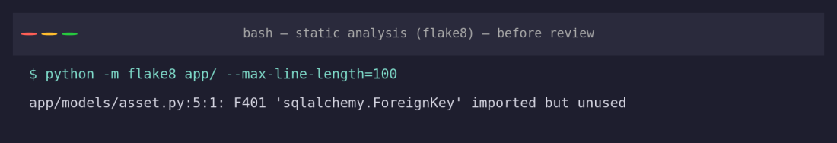
Figure 2: flake8 finding — unused ForeignKey import
This was corrected during the review, and a second, related issue was addressed at the same time: AssetOut used Pydantic's deprecated V1-style class Config instead of the V2 ConfigDict, which pytest was already flagging as a DeprecationWarning. After both fixes, static analysis is clean:
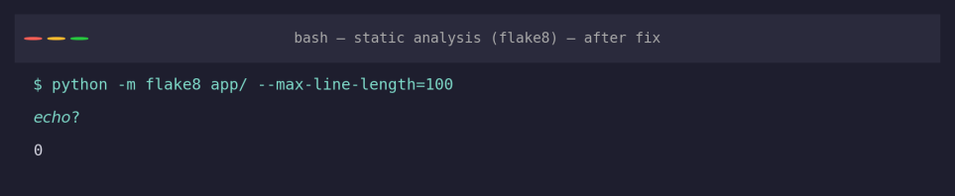
Figure 3: flake8 output after cleanup — zero issues

3.3 Documentation
Every module has a clear, descriptive docstring-equivalent in its structure (small, single-purpose files with self-explanatory names), and docs/project_structure.md explicitly documents the purpose of every top-level folder. However, individual functions do not currently carry docstrings, and the API relies entirely on FastAPI's auto-generated OpenAPI schema (derived from type hints and Pydantic models) for documentation rather than explicit prose — sufficient for a small API today, but worth revisiting as endpoints grow more numerous.

3.4 Strengths
- Consistent use of async/await throughout the data-access layer, matching the async SQLAlchemy engine configured in database.py.
- Clear separation between Pydantic schemas (API contract) and SQLAlchemy models (persistence), avoiding a common anti-pattern of exposing ORM objects directly.
- Small, single-responsibility functions and files that are easy to review and test in isolation.
- Meaningful HTTP status codes and error messages (400 with an explanatory detail for duplicate tracking IDs, 404 for unknown assets).

3.5 Areas for Improvement
- datetime.utcnow() is used in app/routers/telemetry.py and is deprecated in current Python versions in favor of timezone-aware datetime.now(datetime.UTC) — confirmed by a live DeprecationWarning during test execution (Section 5).
- The LOW_BATTERY_THRESHOLD constant is currently hard-coded in telemetry.py; moving it to a central settings module (already partially scaffolded via pydantic-settings in requirements.txt) would make it configurable per deployment without a code change.
- No explicit function-level docstrings; as the router count grows, brief docstrings would improve maintainability for new contributors beyond what auto-generated OpenAPI docs provide.

4. Version Control Evaluation

4.1 Commit History
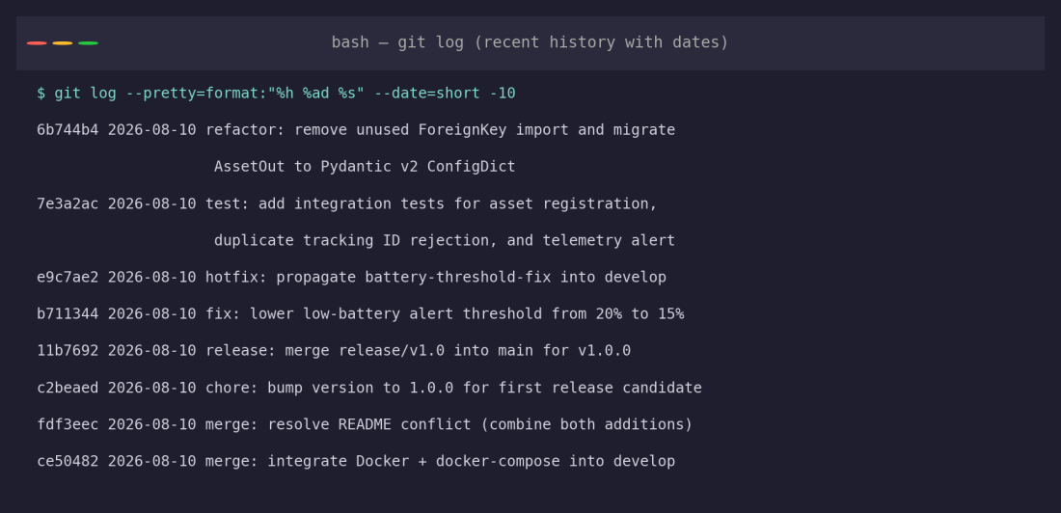
Figure 4: Recent commit history with dates and messages
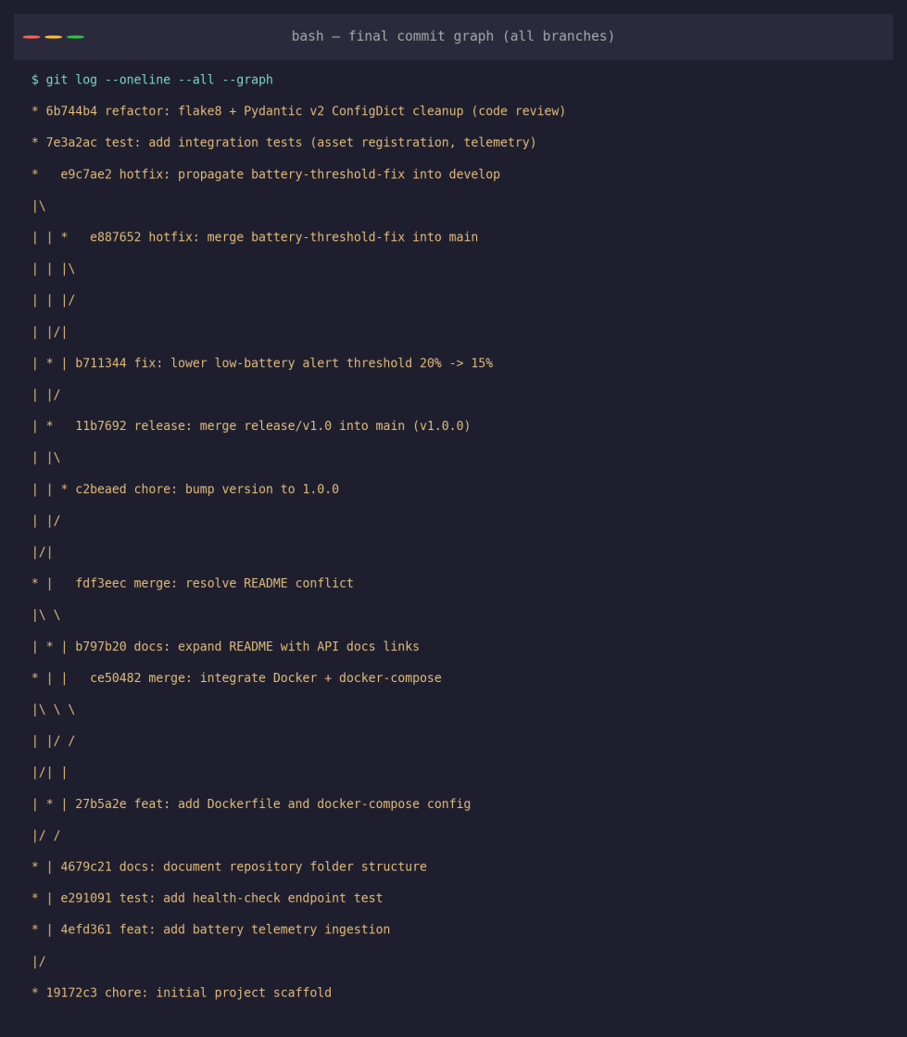
Figure 5: Full commit graph across all branches, including review-driven commits

4.2 Branching Strategy
The repository follows a Git Flow-inspired model with main, develop, feature/*, release/*, and hotfix/* branches, as established in the companion Git & Docker Technical Assignment. This evaluation adds two further commits directly onto develop — one adding integration tests, one applying the code-review fixes from Section 3 — demonstrating that the branch continues to receive incremental, reviewable changes after the initial release.

4.3 Commit Message Quality
Commit messages consistently use a type prefix (feat:, fix:, docs:, test:, refactor:, merge:, release:, hotfix:) followed by an imperative summary, for example: refactor: remove unused ForeignKey import and migrate AssetOut to Pydantic v2 ConfigDict (flake8 + deprecation warning cleanup from code review). This message states what changed, why (the two static-analysis findings), and links the change back to this review — exactly the level of detail that lets a future maintainer understand a change from `git log` alone, without re-reading the diff.

4.4 Repository Maintenance Practices
- Annotated tags (v1.0.0, v1.0.1) mark exactly which commit was released, supporting rollback and audit needs.
- A .gitignore excludes environment files, caches, and virtual environments, keeping the tracked history free of machine-specific noise.
- Fixes discovered during review (Section 3) were committed as a single, clearly labelled refactor: commit rather than folded silently into unrelated work, preserving an honest history of what the review changed.

4.5 How Version Control Supports Collaborative Development
Because features, the release, and the hotfix each lived on their own branch, this review's changes could be applied directly to develop without risk of disturbing the tagged, released state on main. If a second contributor were working on a different router in parallel, the modular file layout from Section 2 combined with this branching model means their work could be merged independently, with Git's merge tooling — and conflict resolution, as demonstrated for README.md in the companion assignment — handling any overlap explicitly rather than silently.
5. Code Testing and Validation

5.1 Test Cases
Test Case | Purpose | Expected Result
test_health_check | Confirms the container health-check endpoint responds correctly | 200 OK, {"status": "ok"}
test_register_asset_success | Confirms a new asset can be registered with valid data | 200 OK, asset returned with status "available"
test_register_asset_duplicate_tracking_id_rejected | Confirms the uniqueness constraint on tracking_id is enforced | 400 Bad Request with explanatory detail
test_telemetry_triggers_low_battery_alert | Confirms battery telemetry below threshold flags maintenance | 200 OK, low_battery_alert: true, status "maintenance_required"
test_telemetry_unknown_tracking_id_returns_404 | Confirms telemetry for an unregistered device is rejected | 404 Not Found

\5.2 Execution Results — Before Review Fixes
The original suite (one test) passed, but surfaced a Pydantic deprecation warning that motivated one of the fixes in Section 3:
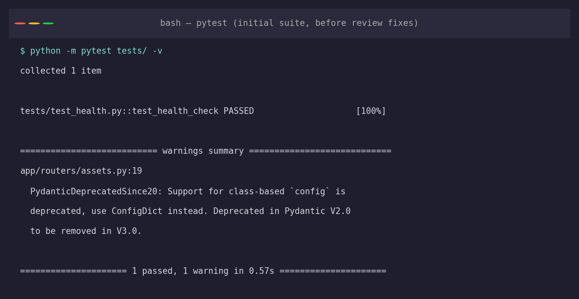
Figure 6: Initial test run — passing, but with a Pydantic deprecation warning

5.3 Execution Results — After Adding Integration Tests and Review Fixes
Four additional integration tests were written against an in-memory SQLite database (overriding the get_db dependency) to exercise the registration, duplicate-rejection, and telemetry logic without requiring a live PostgreSQL instance. All five tests pass:
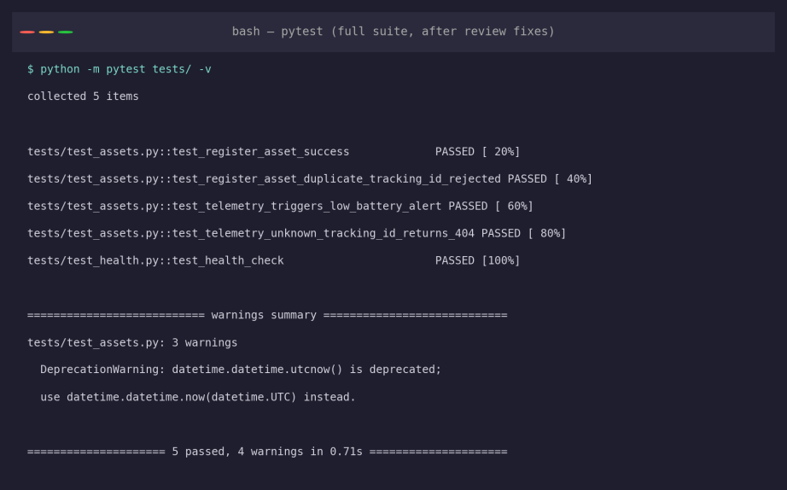
Figure 7: Full test suite after review — 5 passed, Pydantic warning resolved
The remaining DeprecationWarning (datetime.utcnow()) is a genuine, still-open finding carried into the recommendations in Section 7 — it does not affect correctness today but should be addressed before upgrading to a future Python version that removes the deprecated call.
6. Repository Documentation

6.1 Completeness Evaluation
Documentation Element | Present? | Assessment
Project description | Yes | README opens with a clear one-paragraph description of the platform's purpose.
Stack / dependencies list | Yes | README lists backend, database, containerization, and testing stack; requirements.txt pins exact versions.
Installation instructions | Yes | Both Docker and local (virtualenv) setup paths are documented step-by-step.
Usage guide | Partial | Quick-start commands are given, but no example request/response payloads are shown in the README itself.
Environment variable reference | Yes | .env.example documents every variable docker-compose.yml expects.
Repository structure explanation | Yes | docs/project_structure.md gives a full folder-by-folder rationale.
API reference | Partial | Relies entirely on FastAPI's auto-generated /docs; no static endpoint reference in the repository itself.

6.2 Suggested Improvements
- Add a short “Example Requests” section to the README showing a sample curl call for asset registration and telemetry ingestion, so a new developer can validate their setup without first reading the source.
- Add a CONTRIBUTING.md describing the branching model (Section 4) and commit message convention, so future contributors follow the same practices without having to infer them from git log.
- Link directly to the live /docs and /redoc paths from the README so interactive API documentation is one click away after startup.
- Add a minimal architecture diagram to the README itself (not just in the separate project report) so the system shape is visible without leaving the repository.

7. Code Review Findings and Recommendations

7.1 Summary of Findings
Overall, the SmartCare Assets repository is well organized, with a clear separation between API schemas, ORM models, and route handlers, and a disciplined Git history that makes the project's evolution easy to follow. The review identified and resolved two concrete code-quality issues (an unused import and a deprecated Pydantic configuration style) and expanded automated test coverage from one test to five, adding real integration coverage for the asset-registration and telemetry logic that previously had none. One genuine, still-open issue — the use of the deprecated datetime.utcnow() — remains for future work.

7.2 Recommendations
Code quality: replace datetime.utcnow() with datetime.now(datetime.UTC) throughout, and move the LOW_BATTERY_THRESHOLD constant into a shared settings module.
Repository management: add branch-protection rules on main and develop requiring passing tests before merge, formalizing the discipline already demonstrated manually in this review.
Documentation: add example API requests, a CONTRIBUTING.md, and direct links to /docs and /redoc as outlined in Section 6.2.
Testing: extend the integration-test pattern used here (in-memory SQLite override of get_db) to cover the search endpoint and additional edge cases, such as invalid battery values.
Future enhancements: introduce a CI workflow that runs flake8 and pytest automatically on every pull request, so the checks performed manually in this review happen continuously rather than only at review time.

